Scientific Computing

MATH6183001

Lecturer: Don Tasman, S.Mia, S.E, S.Si, S.S, M.M (D 1805)

Books:

1. Kong, Q., Siauw, T., and Bayen, A. M. (2021). Python Programming and Numerical Methods: A Guide for Engineers and Scientists. Amsterdam: Academic Press, Elsevier.
2. Jaan Kiusalaas (2013). Numerical Methods in Engineering with Python 3 (3rd Edition). United Kingdom: Cambridge University Press.

Theory: ASG = assignment 10%

Theory: Mid Exam 20%

Theory: Final Exam 30%

Lab: Assignment 30%

Theory: AOL = assurance of learning 10%

**Numerical Method**

**Numerical methods** are techniques by which mathematical problems are formulated so that they can be solve with arithmetic operations.

**Computational science, also known as scientific computing or scientific computation (SC)**, is the collection of tools, techniques and theories required to solve on a computer mathematical models of problems in science and engineering.

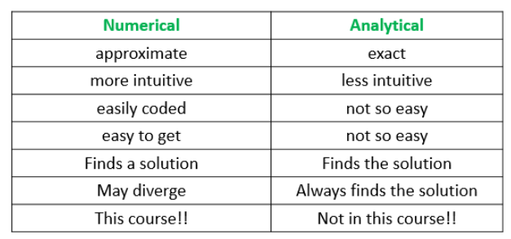

Why do we use the numerical method?

1. If there is no direct formula.

2. If it is very hard to do exactly.

3. If it cannot be calculated directly.

What can be solved numerically?

1. System of Linear Equations

2. Regression and interpolation

3. Taylor Series

4. Root of equations

5. Numerical Differentiation

6. Numerical Integration

7. Ordinary Differential Equations.

**Binary and Decimal**

Convert the binary 1110.1011 to decimal

Convert again to binary.

Accuracy is related to the closeness to the true value.

Precision is related to the closeness to other estimated values.

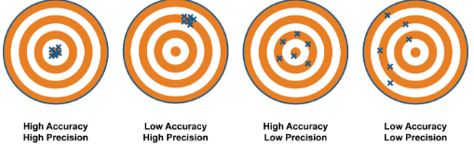

In numerical method/analysis, we will minimize the error and increase efficiency.

**Errors:**

Numerical errors arise during computations due to round-off errors and truncation errors.

Rounding: the closest number chosen by the computer

Chopping: throw all extra digits.

**Modelling Error**

This error results in deriving the mathematical equation or using a model that does not describe adequately the physical system under study. Ex: modelling the falling-down object without considering the air resistance.

**Some Fundamental definitions of Error Analysis:**

Absolute Error: Suppose that xt and xa denote the true and approximate values of a then the error incurred on approximating is given by

$ e=x_{t}-x_{a}$

and the absolute error ea  i.e. magnitude of the error is given by

$ e_{a}=\vert x_{t}-x_{a}\vert$

*Relative Error:*Relative Error or normalized error er  is defined by

$ \displaystyle{e_{r}=\frac{absolute\quad error }{\vert true\quad
value\vert}=\...
...t x_{t}-x_{a}\vert}{\vert x_{t}\vert}=\big\vert 1-\frac{x_{a}}{x_{t}}\big\vert}$

and $ \displaystyle{e_{r}\% = e_{r}\times100}.$

Sometimes er is defined by

$ e_{r}=\vert\frac{x_{t}-x_{a}}{x_{a}}\vert=\vert 1-\frac{x_{t}}{x_{a}}\vert$

$ Eg:$ If xt=1434 and xa=1464 then

$ e=x_{t}-x_{a}=1434-1464=-30$

$ e_{a}=\vert x_{t}-x_{a}\vert=\vert-30\vert=30$

$ e_{r}=\frac{e_{a}}{x_{t}}=\frac{30}{1434}\simeq 0.020921$

$ e_{r}\%=2.0921$

**SYSTEM OF LINEAR EQUATIONS**

Solve the system of linear equations:

$$\left\{\begin{aligned}x+y+z=4 \\ x-y-z=-2 \\ 2x+8y+z=19\end{aligned}\right.$$

a. Using Gauss elimination

b. Using Gauss-Jordan

A=LU decomposition

Example:

$A=\left(\begin{matrix}1 & 1 & 1 \\ 1 & -1 & -1 \\ 2 & 8 & 1\end{matrix}\right)$

Write A as LU.

Using Doolittle’s decomposition method to solve:

$$\left\{\begin{aligned}x+y+z=4 \\ x-y-z=-2 \\ 2x+8y+z=19\end{aligned}\right.$$

AX = B is changed into LUX = B (A= L.U)

UX = Y, so LY = B

Find yi from LY=B and then solve xi from UX = Y.

Methods for solving system of linear equations are Gauss elimination, Gauss-Jordan or Gauss-Seidel method. But if there are extremely large or extremely small elements in the matrix, these methods **will not** succeed, if the diagonal element **is not dominant** or if **scaled row pivoting** is not performed.

In mathematics, a square [matrix](https://en.wikipedia.org/wiki/Matrix_(mathematics)) is said to be **diagonally dominant** if, for every row of the matrix, the absolute value of the diagonal entry in a row is larger than or equal to the sum of the absolutes of all the other (non-diagonal) entries in that row.

**PIVOTING**

Solve:

$$\left\{\begin{aligned}-2x+4y-z=1 \\ x-y+3z=3 \\ -4x+2y-z=-3\end{aligned}\right.$$

Using diagonally dominant (absolute value of each diagonal element should be dominant)

Example:

$$\left\{\begin{aligned}2x+y+z=4 \\ x+3y+z=5 \\ 2x+y+8z=11\end{aligned}\right.$$

Notice that this system is already diagonally dominant.

Solve with Gauss-Seidel method. Acceptance error = 12%. Initial values (0,0,0). Use 4 d.p.

The pivoting technique is used to avoid round-off errors that could be caused when dividing every entry of a row by a pivot value that is relatively small in comparison to its remaining row entries.

Example:

$$\left\{\begin{matrix}-0.46x+y=1.1 \\ -0.5x+y=1\end{matrix}\right.$$

Notice that the system has exact answer: {(2.5, 2.25)}.

Solve for x and y with Gauss elimination (use 2 d.p)

If diagonally dominant does not exist, use **scaled row pivoting**.

Example:

$$\left\{\begin{matrix}-0.46x+y=1.1 \\ -0.5x+y=1\end{matrix}\right.$$

a. Check that {(2.5, 2.25)} is the exact answer

b. Use scaled row pivoting and Gauss elimination.

c. What is your conclusion?

Example:

$$\left\{\begin{aligned}2x-2y+6z=16 \\ -2x+4y+3z=0 \\ x-8y-4z=1\end{aligned}\right.$$

**Gauss-Seidel**

Given a system of linear equations and initial value for each xi.

Find the new xi and stop if

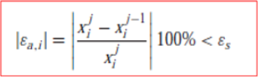

εs = error tolerance.

Example:

$$\left\{\begin{aligned}4x-y+z=12 \\ x-4y+2z=1 \\ x-2y+4z=5\end{aligned}\right.$$

Find x, y, z using Gauss-Seidel with initial value {(0,0,0)}, using 4 d.p and error tolerance 12%.

Remark: it is already diagonally dominant.